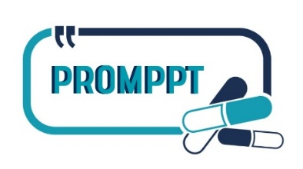
Pain Review Plan & Self-care Information

All the resources suggested in this leaflet are available online via the PROMPPT website. To access the resources, you can either:

Scan the QR code below using the camera on your smartphone

or

Click here or enter the following link into your internet browser

https://www.promppt.co.uk/protected/resources.html

Your PROMPPT username is: user  Your PROMPPT password is: info2023 | SCAN ME  SCAN ME | SCAN ME

Pain review plan
Thank you for coming to see me, here is a brief reminder of the pain management plan we agreed for you:

We have agreed to have another appointment together YES ☒ NO ☐
Your next appointment is on Friday 11 November 2021 at 09:00.
If you need to contact me, please call 01782 000111.
I will get back to you as soon as I can.

Self-care information
Based on our discussion, I have ticked the areas I think are most important to you to find out more about.
Please have a look at any of the information that is of interest to you. You may also like to share this information with family and friends to help them understand so that they can support you.
All the information is available online. You can find it by following the instructions on the front page of this leaflet and entering the username and password provided.

Some of the information resources listed are written leaflets for you to read, some are websites and some are videos you can watch.
If you have told me that you do not have access to the internet and/or prefer printed information, I will provide you with paper copies of the information leaflets.

Understanding persistent pain
Understanding persistent pain and what to do about it
Understanding pain in less than 5 minutes and what to do about it (5 minute video)

Learn about self-care steps you can take

to live well with pain
Ten Footsteps: Your journey to living well with pain
Exercise and being physically active when reducing opioids
Pacing: A really useful skill for people with pain
Pain and driving: Information for people taking prescribed pain medicines
Pain and sleep: How to sleep well with pain

Opioids & persistent pain – what’s the problem?
The problem with opioids and persistent pain
Which medicines are opioids and which are not (1 minute video)
Brainman stops his opioids (2 minute video)
Opioid medicine reviews: some information

Reducing opioids – what to expect & what might help
What to expect when you reduce opioids and what might help
Louise’s story. Find out about Louise’s experience of stopping opioids and how she found walking helpful (7 minute video)
Lisa’s story. Find out about why Lisa decided to make changes to her pain medicines and how keeping in mind what was important helped her do this (4 minute video)
Sean’s story. Find out how Sean found tai chi and mindfulness helpful when coming off opioid medicines (5 minute video)

